Wireshark Lab IP
CSCE 560
19 Nov 18
Marvin Newlin

Note: This lab was done using the trace provided by the lab instructions since AFIT’s network doesn’t allow ICMP traffic from traceroute to work.

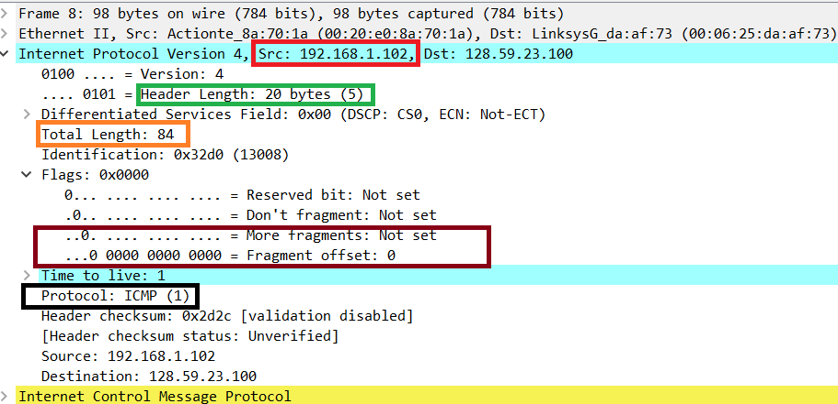

- Select the first ICMP Echo Request message sent by your computer and expand the Internet Protocol part of the packet in the packet details window. What is the IP address of your computer?
Sol’n: As indicated in the red box, the source IP address is 192.168.1.102.
- Within the IP packet header, what is the value in the upper layer protocol field?
Sol’n: The black box shows that the protocol is Internet Control Message Protocol (ICMP).
- How many bytes are in the IP header? How many bytes are in the payload of the IP datagram? Explain how you determined the number of payload bytes.
Sol’n: The green box shows that there are 20 bytes in the header. The Orange box shows that the total length of the datagram is 84 bytes, so the payload should be 84-20 = 64 bytes.
- Has this IP datagram been fragmented? Explain how you determined whether or not the datagram has been fragmented.
Sol’n: In the burgundy box we see that the more fragments field is 0 and the offset is 0. This means that there is only one datagram so the datagram has not been fragmented.

Next, sort the traced packets according to IP source address by clicking on the Source column header; a small downward pointing arrow should appear next to the word Source. If the arrow points up, click on the Source column header again. Select the first ICMP Echo Request message sent by your computer and expand the Internet Protocol portion in the “details of selected packet header” window. In the “listing of captured packets” window, you should see all of the subsequent ICMP messages (perhaps with additional interspersed packets sent by other protocols running on your computer) below this first ICMP. Use the down arrow to move through the ICMP messages sent by your computer.

- Which fields in the IP datagram always change from one datagram to the next within this series of ICMP messages sent by your computer?
Sol’n: Within the IP portion, the Identification, time to live, and header checksum always change.
- Which fields stay constant? Which of the fields must stay constant? Which fields must change? Why?
Sol’n: The flags, source and destination IP, and the protocol always stay the same. The TTL, header checksum, and Identification always change. The TTL has to change because otherwise we wouldn’t be able to map this way. The header checksum changes because the TTL field and Identification fields change. The identification field changes because the ID is unique to each datagram.
- Describe the pattern you see in the values in the Identification field of the IP datagram
Sol’n: It decrements by one each time just like the TTL field.

Next (with the packets still sorted by source address) find the series of ICMP TTL-exceeded replies sent to your computer by the nearest (first hop) router.

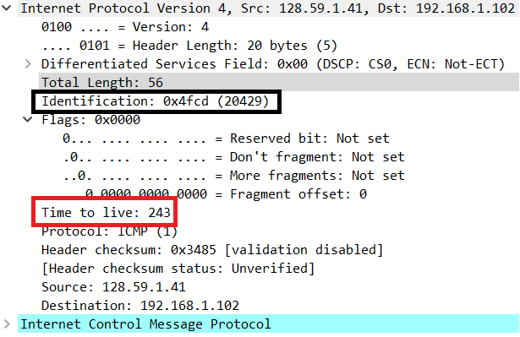

- What is the value in the Identification field and the TTL field?
Sol’n: The black box shows that the ID field is 0x4fcd (20429) and the red box shows the TTL is 243.
- Do these values remain unchanged for all the ICMP TTL-exceeded replies sent to your computer by the nearest (first hop) router? Why?
Sol’n: The TTL stays the same for the first six TTL exceeded messages, but the ID field changes each time because each datagram is different. The TTL exceeded message happened because the datagram’s TTL field has reached 0 so it means that six packets that reached that destination all had their TTL decremented to 0 without reaching the destination host. ICMP echo messages are sent in triplicate and since each message is fragmented twice, there are 6 messages.

Fragmentation

Sort the packet listing according to time again by clicking on the Time column.

- Find the first ICMP Echo Request message that was sent by your computer after you changed the Packet Size in pingplotter to be 2000. Has that message been fragmented across more than one IP datagram? [Note: if you find your packet has not been fragmented, you should download the zip file http://gaia.cs.umass.edu/wireshark-labs/wireshark-traces.zip and extract the ip-ethereal-trace-1packet trace. If your computer has an Ethernet interface, a packet size of 2000 should cause fragmentation.]
Sol’n:
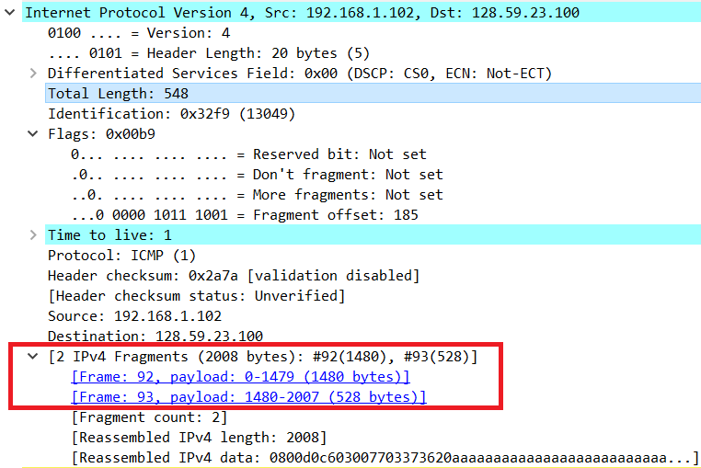
In the red box we can see that the packet was fragmented into two datagrams.

- Print out the first fragment of the fragmented IP datagram. What information in the IP header indicates that the datagram been fragmented? What information in the IP header indicates whether this is the first fragment versus a latter fragment? How long is this IP datagram?
Sol’n:
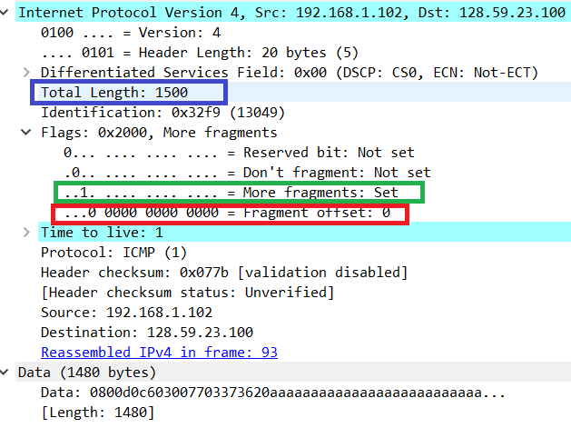
In the green box we see that the more fragments flag is set so this indicates that this datagram has been fragmented. The red box shows us the offset which is 0 indicates that this is the first fragment being sent. The blue box shows us that the datagram is 1500 bytes long, with a payload of 1500-20 = 1480 bytes.

- Print out the second fragment of the fragmented IP datagram. What information in the IP header indicates that this is not the first datagram fragment? Are there more fragments? How can you tell?
Sol’n:

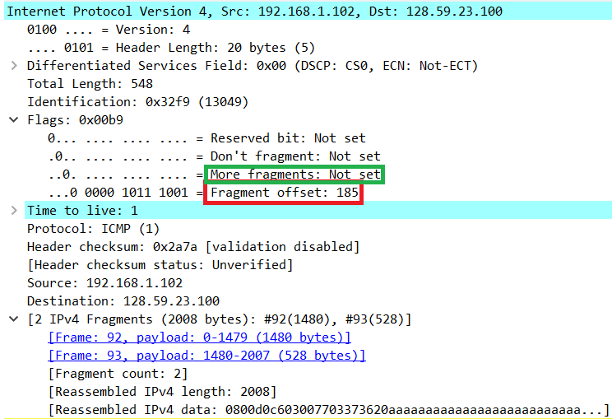

The offset is set at 185 (1480/8) (green box) indicating that this is not the first fragment since the offset is not 0. The red box shows that the more fragments flag is not set meaning there are no more fragments.

- What fields change in the IP header between the first and second fragment?
Sol’n: The total length, the more fragments flag, the offset flag, the checksum, and the identification fields change.

Now find the first ICMP Echo Request message that was sent by your computer after you changed the Packet Size in pingplotter to be 3500.

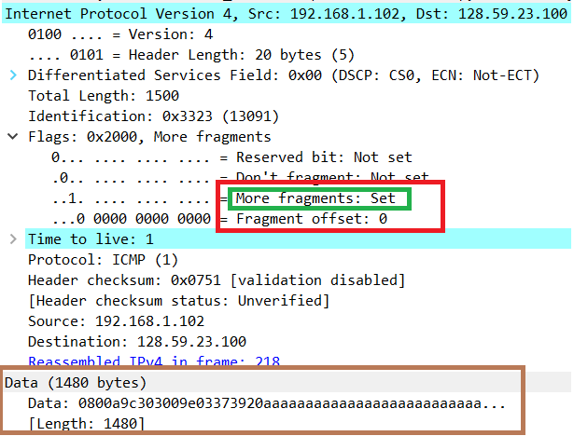
Fragment 1

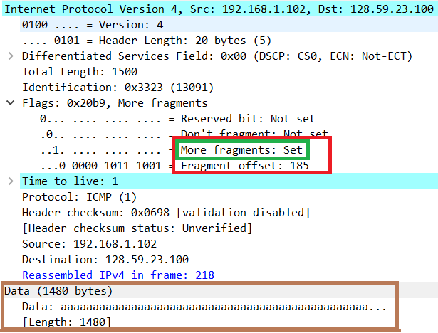
Fragment 2
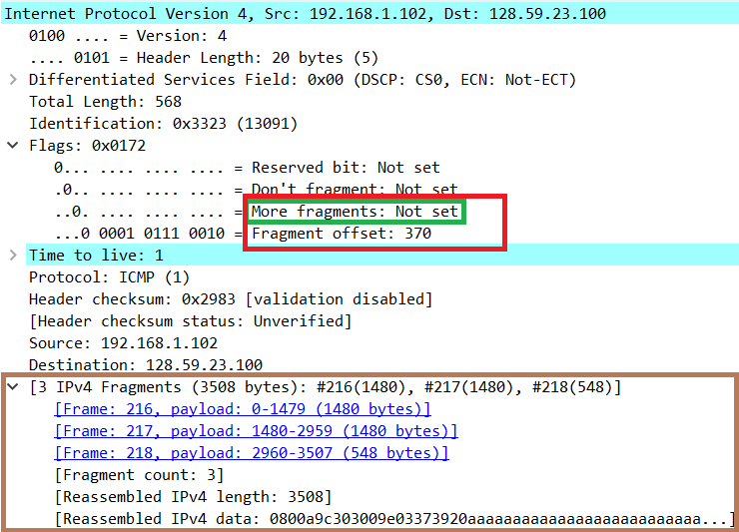
Fragment 3

- How many fragments were created from the original datagram?
Sol’n: Since we are sending 3500 bytes with a MTU of 1500 bytes we expect 3 fragments which is indeed what we get (pictures above)
- What fields change in the IP header among the fragments?
Sol’n: Just like all other packets, the checksum and identification fields and length fields change. In the red and green boxes in each of the above pictures we see that the important flags that change between fragments are the more fragments and fragment offset fields.

